My Circumcision Story by Scott
This is the story of my circumcision and the build up to it. I was born in a small town in Western Canada in 1960 where the circumcision rate was well over 90%. I have no idea why I was left intact other than the fact that my father was not circumcised. My foreskin was typical, long with about a fair bit of overhang. I had enough skin to even cover the head while erect, although it did roll back easily.

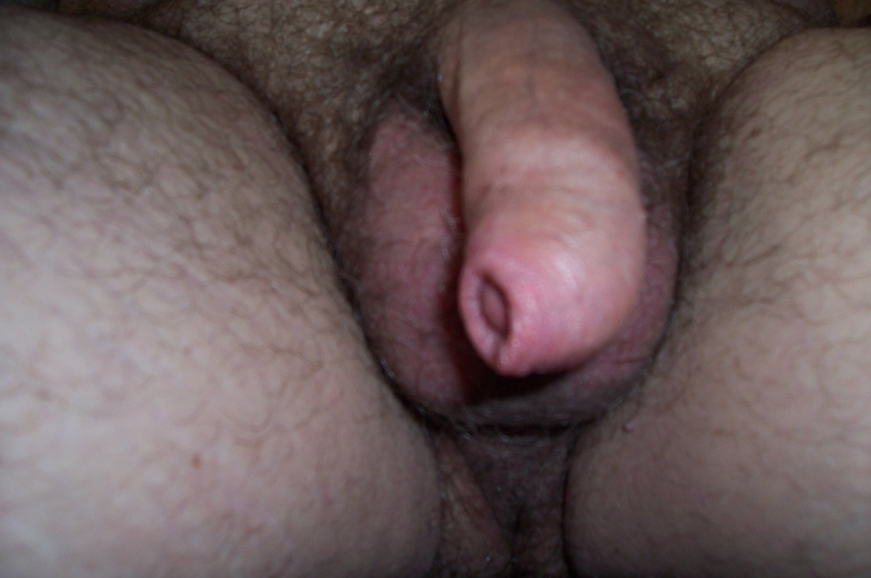
Uncut soft

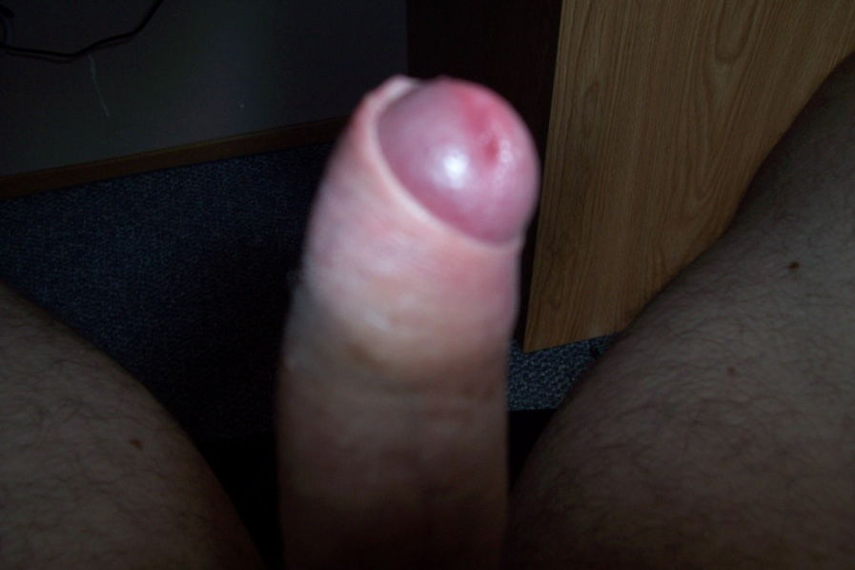
Uncut Semi – retracted

My first sexual experience was with a cousin who was one year older than me, I was 13 & he was 14. Glenn taught me how to jerk off, and we often jacked in front of each other, and sometimes did each other. He was circumcised but it didn’t click in my mind for some time that his cock was different than mine. Sometime after he taught me how to jerk off, I showed a friend by the name of Steven how to jerk off as well. One time when we jerking together he commented that there must be two different kinds of cock, one with skin like mine, and one like his without. This was the first time I realized I was different
I really didn’t understand or care about any difference until about a year later when a 15 year old female cousin took my virginity in the back seat of her Dad’s car. When she pulled my dick out of my pants she was shocked to find me uncut and said she wouldn’t suck on it, but would have intercourse with me. After we were done she said I should get my cock fixed since I still had all that gross skin. As I entered junior high school and then high school, I had the opportunity to see other guys naked in the locker room. It turns out that I was the only uncut guy to be seen. I got lots of sneers and laughs, along with several snide comments about my foreskin. As a result I became very conscious of my foreskin and would try to hide my uncut status.

Over the ensuing years I had lots of sexual opportunities with both guys and girls. Most weren’t happy to find me uncut; a few would even refuse to have sex with me as a result. As an adult I was present in groups where circumcision was often discussed and everyone was for it. Several girls said they might screw an uncut guy, but would never suck him off. I played along and never said I was uncut. I never saw another uncut guy until I was well into my 20’s. All my friends had beautiful cut cocks; the GOMCO clamp had been busy.

I got married at age 25 to a very naive virgin who knew nothing about circumcision, so my foreskin was never an issue to her. As newlyweds we had sex several times a day, and problems with my foreskin began to happen. At first it was a torn frenulum and a very inflamed foreskin caused by frequent sex. The first doctor I saw recommended a circ` `so I wouldn’t have a sore cock the rest of my life`` - his actual words. He told me I would regret it if I didn’t have it done. As much as I liked the idea of circumcision, I enjoyed uncut sex and was afraid of the pain and embarrassment of having it done, so I didn’t get cut.

As the years went by the frenulum problem went away, but I had constant infections of the foreskin. Doctors would prescribe creams and ointments which would help, but only temporarily. I asked another doctor at this time about a circumcision and he was supportive, but again I never asked to have it done. As I got older my main source of sexual pleasure was through masturbating, which was easy to do and very pleasurable with a foreskin. The thought of cutting of this piece of skin and wrecking my only source of sexual pleasure terrified me. As I got into my 40’s the infections were almost constant and were very painful, and it became clear that something had to happen.

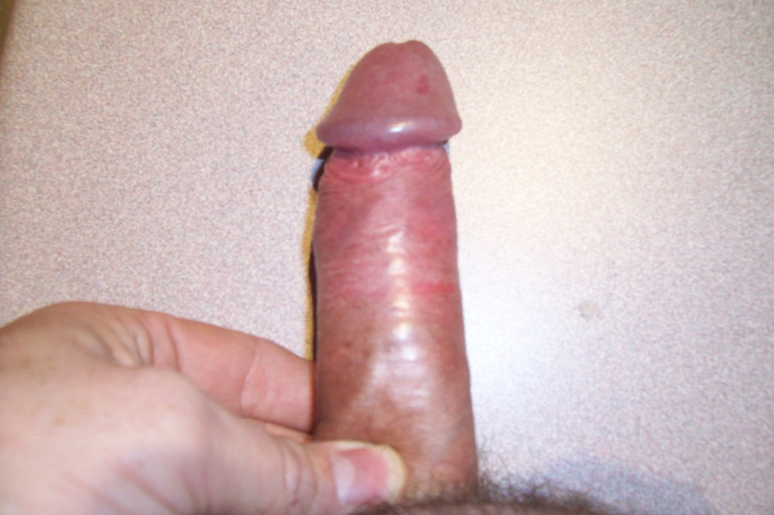
Uncut retracted – hard to see but red and inflamed in middle of shaft
By this time I had a new doctor who was someone I liked allot. I worked my courage up to ask him how I would go about a getting a circumcision. He took a quick peek at my file and noticed that I have been treated several times for foreskin problems. This GP told me he would refer me to the local urologist with my request for a circ. I had to wait about 4 months to see the urologist, which was both scary and exciting.

Finally in September of 2006 my appointment arrived. When the doctor walked in the room he said he understood that I wanted a circumcision and asked if I was having problems. I told him about the infections and he went onto tell me that a circumcision for guys our age were not fun (I was about to turn 46, he was maybe 48). I said I knew but wanted it done anyway. He said he could do it and began to fill out a surgery request form for me to sign. In response to some questions I raised, he told me he was from South Africa and had probably done 1000 adult circumcisions. He also told me that every urologist he knew used the freehand scalpel method, no one he knew used “bells or clamps”. I asked him if we should discuss how much skin to remove, but he said he would take off what was necessary, which was the only down part of the visit. I had wanted to discuss this in greater detail. Surprisingly he never asked to see my foreskin.

I had to wait about 8 weeks for the day of the operation to arrive. December 1, 2006 was circumcision day, something I was both looking forward to and dreading. I had never gone more than 3 or 4 days with an orgasm in my whole life, and knew I would be out of action for a few weeks. As a result I jerked off 3 times the night before, and early in the morning before the surgery.

I arrived at the hospital at 6:30 AM and sat in the waiting room for about 30 minutes. I began to worry if I was doing the right thing, and if I would regret being cut. At 7:00 AM I was called inside, changed into a hospital gown and had my vital signs taken. At this point I felt really embarrassed to be having a procedure down as a grown adult that I should have had done as a baby. I was then given a bed in the pre-op area to wait for my 8:00 AM scheduled surgery. I have to say that the nurses were fantastic, and I had no reason to feel embarrassed. It turns out they do adult circs every week, and to them I was just another patient, and just another procedure.

At 8:00 AM I was rolled into the operating room for my circumcision. The young OR nurse was very kind and understanding. She asked if I had sons and if they were circumcised. I told her that I had two teenagers who were both uncut. I had wanted them cut to avoid what I had gone through but my wife refused. The nurse told me that it was a tough decision but she and her husband had circumcised their son. While we were talking she was cleaning my groin with an antiseptic, and rolled back my foreskin to do the same with the glans.

The urologist arrived and gave me two injections into the base of my penis. He tested my foreskin a moment later by touching it with the tip of a scalpel. Since I could feel the scalpel he gave me 2 more injections into the base of my penis. When he tested a minute later I had no feeling at all, and he began the circumcision. As he worked on my dick, I could feel the movement and tugging but no pain. It only took about 10 minutes and I was done. Finally after 46 years I was now circumcised. As I slid off the OR table onto a stretcher I happened to see a huge pile of sponges that had been used to soak up the blood. I was surprised to see such a large pile, I guess I bled a fair bit. Once I arrived in the recovery area, I had the first chance to look at my cock which was tightly wrapped in a thick bandage from just below the pee hole to near the base. At 9:00 AM I went home.

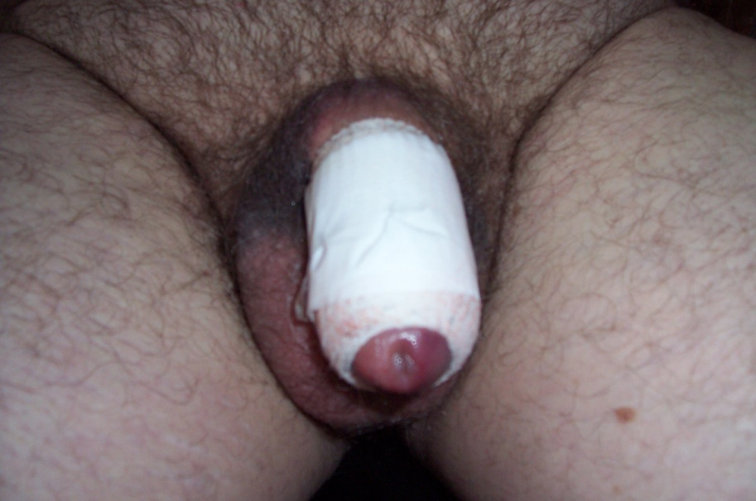
Finally cut – notice the bruising on the scrotum

The only pain I felt after the circumcision was at home on the first day which was easily solved by Tylenol 3`s. It took my last Tylenol at 6:00 AM the next morning, and didn’t realize until about 14 hours later that I hadn’t needed to take any more pain killers. The only pain, which was very, very mild, was the day of the operation itself.

I was cut on a Friday, took it easy all weekend, but was able to everything I normally do. I returned to work on Monday feeling fine. Now to be clear my cock was very tender and I had to be gentle when peeing, dressing etc. I made it a point to get up several times the first few nights to pee and hopefully avoid night time erections, which did seem to help. I did have the odd semi-erection which hurt somewhat but never had a full blown hard on, thank goodness.
The urologist had said I could take the bandage off after 3 or 4 days by soaking in the tub which I did on the 4th day. When I took it off I was surprised to see how awful my dick looked. I was black and blue from the glans down to my testicles and badly swollen. It looked awful, almost like the Hunchback of Notre Dame! However it only took about a week or so for the swelling to go down, and the black and blue to go away.

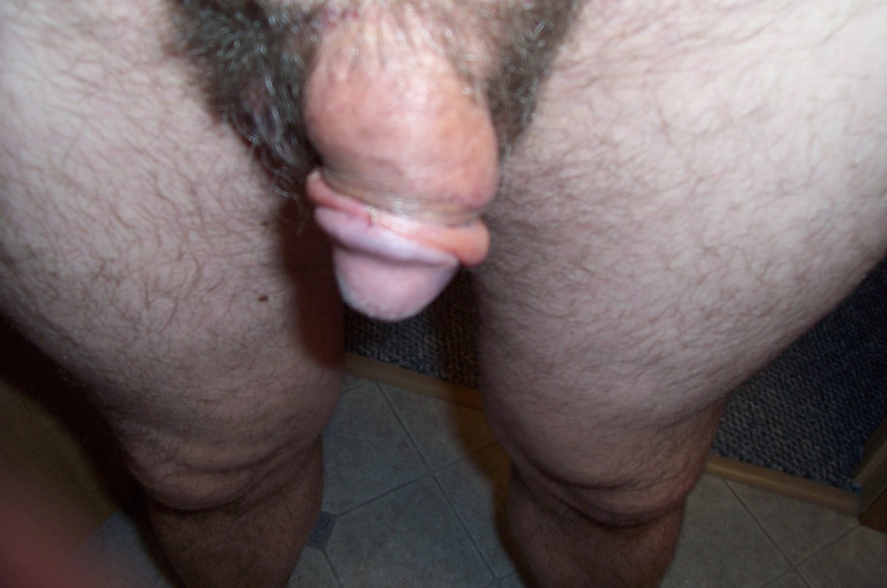
Bandage off on Day 4

My urologist had also told me that I could remove the sutures at the 3 week mark if they were still in. Everything I have read said they should be out somewhere between the one and two week mark, so I had my wife remove them at the end of 2 weeks which felt great. After two to three weeks my cock began to look like most cut cocks with it’s totally bare glans. The newly exposed inner skin beneath the head was still very pink though, and the scar quite prominent.

One of my worries was going so long without sex. The urologist had told me ``no intercourse`` for 4 weeks. I had no sexual desires for the first 2 weeks, but became very horny after that. I jerked off very carefully using lube on day 17. I came quickly and shot the hugest load of semen I ever had, which felt great. I waited another week before jerking off again. I had sex with my wife for the first time at about 5 weeks post circ, and had a blow job from a guy at about the 6 week mark.

One thing that helped make my circ easier is that while I was waiting to see the urologist, I simulated being cut as best I could. I tried to keep my foreskin retracted (which worked most of the time), and I jerked off with my skin held tightly back, forcing me to stroke my bare glans. I think this eased the transition to being cut. It was one less thing that I had to adjust to after the actual cut.

So what’s it like to be circumcised, in a word FANTASTIC! After 40 plus years my dick finally looks like everyone else’s, and I feel so much manlier in locker rooms and while standing at a urinal. My cock never smells which it did when I was uncut even though I kept it very clean. Also when I pee there is no dribble, something that the foreskin always caused to happen which I hated. Most important of all the infected skin has been cut off, and my dick never hurts!

So how’s my sex life now that I’m cut, well that’s interesting. First of all my cock is never sore, so that in itself makes sex better. As well most people are used to guys being cut, so no one is turned off by my cock, thus sex is never refused.

I would say that oral sex and intercourse are the same as before. My foreskin used to roll back easily and would stay back when I wanted it to. I also kept it back while having sex, so I don’t notice allot of difference now that I’m cut.

The only real change is with masturbation. Jerking off is a little harder now, but not allot. It was so easy before, slide the skin back and forth over the head and then you cum. Now being cut it takes a little longer to cum and the sensations are a bit different. Don’t get me wrong though, jerking off is still good, just different. If jerking off uncut was 9 out of 10, jerking now that I’m cut is 8.5 out of 10. Still very good. I’m lucky to have enough loose skin so that I don’t need to use lube to jerk off.

The only down side to my circ is that it is fairly loose. I had hoped for a moderately tight cut, but that was not to be. However I am circumcised and the head of my cock is always bare. There is a ridge of skin bunching up behind the glans, a look I have always liked. Despite that I think my cut cock looks pretty good!

One of the side benefits is the growth in the size of my glans. I have heard reports from other guys who found that their cock head flared out post circ, and that is certainly true with me. When I was uncut my cock looked quite small when soft. Now that I’m cut it is longer soft, and the head is much bigger. I’m still about 6``when hard, but I seem to be thicker.

I told you at the beginning that when I was in my early 20`s, a doctor told me I would regret not being circumcised at that point, which turns out to be so, so true. I wish I had been cut at birth, and since I wasn’t I wish I had listened to the doctor in my 20`s.

I was teased and ashamed of my cock for most of my life, and put up with infections and pain for way too long. It feels great to be cut, and I would urge any guy that is thinking about it to get it done. The operation is very tolerable, there is very little pain, and the recovery is easy. There was no reason for my embarrassment about being cut as an adult, and my fear about hurting my sex life was unfounded. Overall I am very happy to have undergone a adult circumcision.

FYI, I live in a small city of about 45,000 people in Western Canada.

This is a true story. Here are some photos to show how I look at 9 weeks and 1 year later:
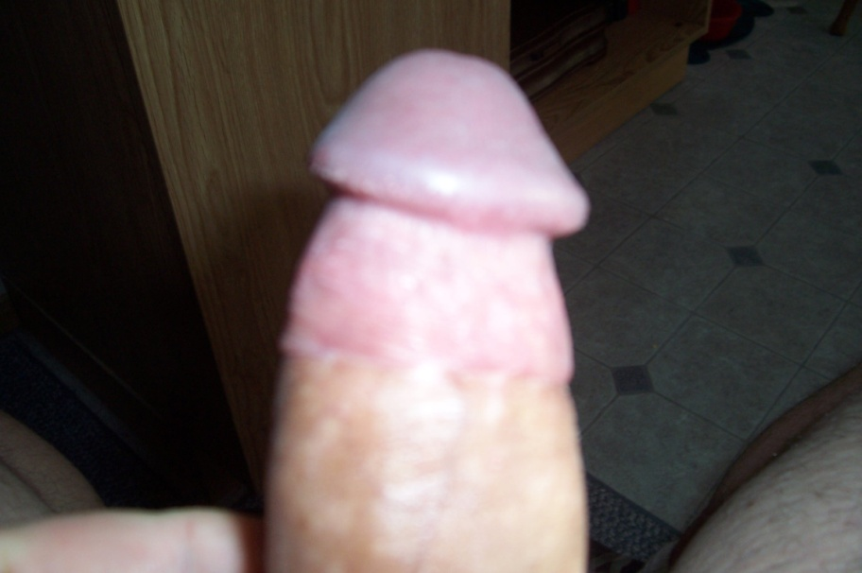
9 Weeks post circ
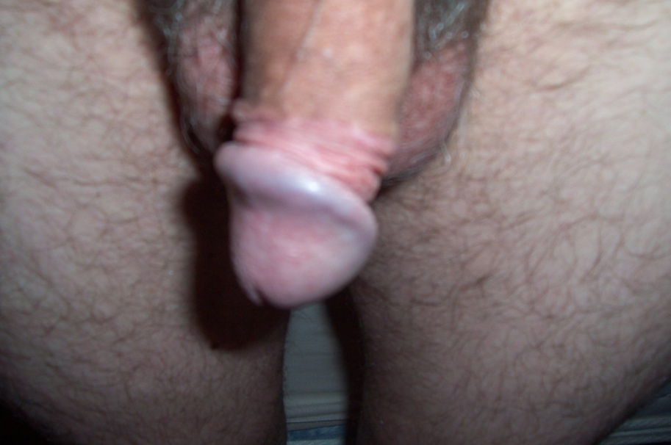
1 year post circ
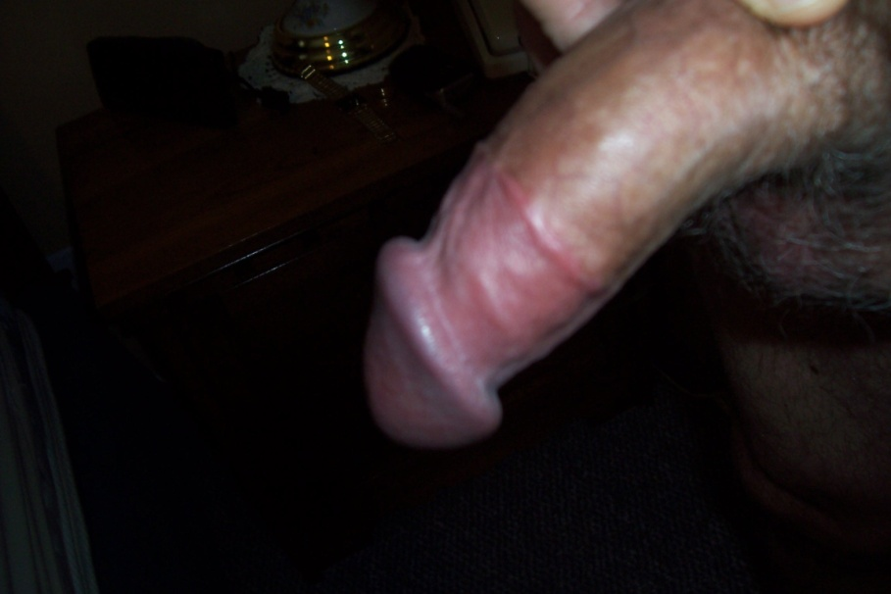
1 year post circ

